18.03.2016

**Impedance difference between Matlab and DigSilent.** Maximum values of impedance peak points undoubtedly depend on the step size used in calculation. I think, theoretically, impedance at this particular frequencies should go to infinitive values. This is definitely the reason in matlab (impedance goes to very high values for small step sizes), but in DigSilent it reaches value of about 12.5kΩ even for very small step size and it does not increase more (with automatic step size checked all the time).

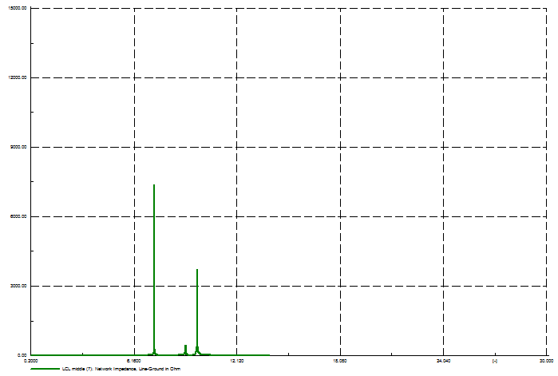

**Step size: 0.1**

**with automatic step size adaptation**

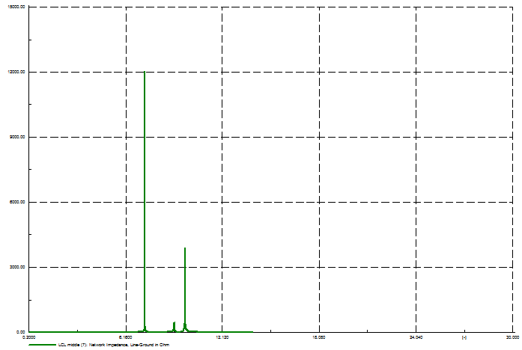

**Step size: 0.01**

**with automatic step size adaptation**

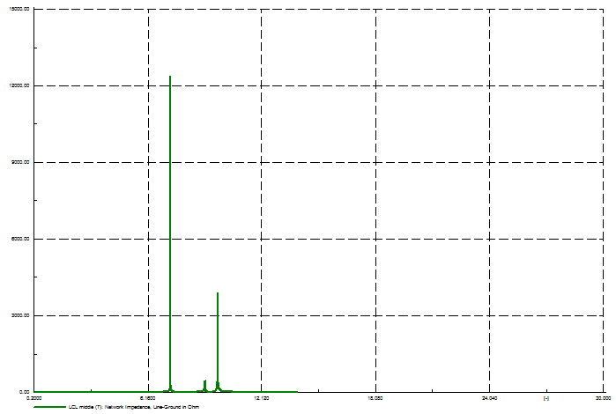

**Step size: 0.00001**

**with automatic step size adaptation**

Thus, I am not sure why it does not go to infinite in DigSilent however, we don’t know how exactly these values are calculated and since there are resistances in the circuit and also some embedded elements like buses/terminals, external grid, groundings, maybe they influence the value of impedance.

**Groundings / current sources instead of WTs.** I used groundings since in calculation of impedance I had calculated equivalent impedance that is seen from middle LCL filter point as parallel impedance of: 1) equivalent impedance of all elements to the right (including rest of branches); 2) shunt capacitor of LCL filter and 3) impedance of elements to the left – only one last coil of LCL filter before WTG.



Seems like DigSilent treats ideal current source like open circuit, what makes sense, therefore the results of frequency sweep are the same for bus with current source and bus with no element connected at all. Of course results of power flow are different depending on the current value. And, analogically, DigSilent consider Voltage Source as ideal zero-impedance, therefore the results are the same for voltage sources and for groundings (I have performed similar analysis in matlab and it confirms that I source = open-circuit and V source = short-circuit).

However, results for grid with current sources/no elements and voltage sources/groundings are different.

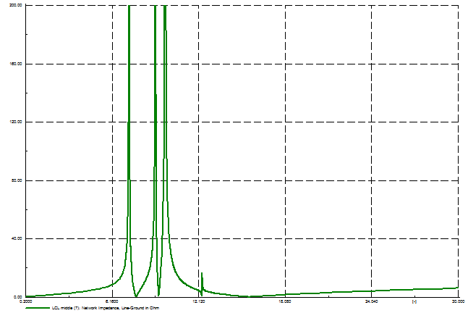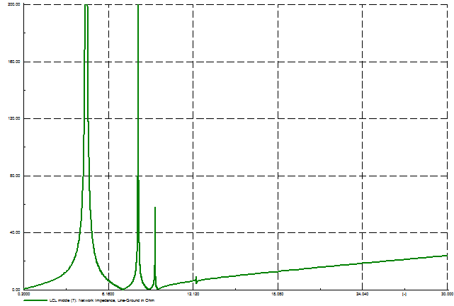

**one I source/one open circuits**

**(at WT bus of first, observed, branch)**

**V sources/earthings**

For case with current sources/open circuits there is no even feasible power flow if all of the buses are opened, thus the right graph above is for only first bus with current source and the rest grounded or with Volt Source, like before. I have used required values of current and some others, but have not obtained feasible power flow yet (max number of iteration is reached). Anyway, they are different for sure.

**About the source of harmonics (which elements).** I have tried to perform sort of analysis in order to detect elements responsible for emission of harmonics in WPP. However, as I read later, the frequency sweep (impedance sweep) analysis is quite limited and from it *“no conclusion can be taken regarding which buses or components have higher participation in exciting resonances (…)”.* These sort of statements I have found in some papers.

Anyway, what I did is analysis, for particular harmonic separately, of influence of every element on total impedance seen from the same bus ( ) like before. I have used simple 1 branch case:

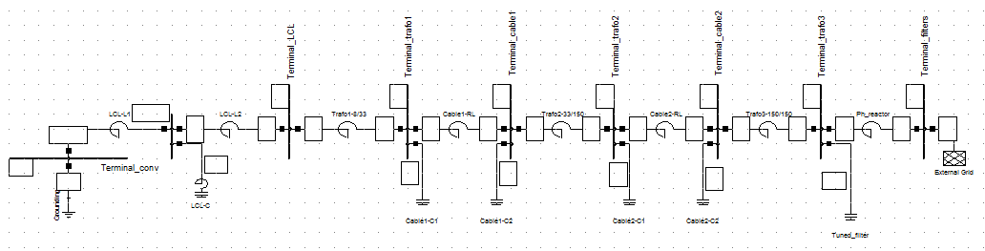

For this example, from frequency sweep we can see that harmonics are:

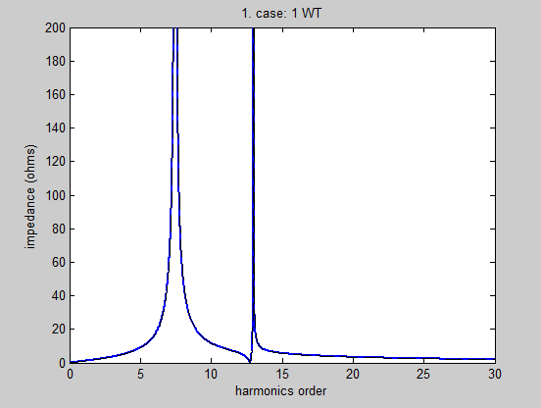

So, there are two values 7.5 and 13 when impedance peaks.

In my analysis, I have obtained results of impedance for different values of each L and C elements, separately. Their values are changed from 1% to 300% of original value.

Below, you can find exemplary graphs of such a analysis for four elements: impedance in LCL filter, impedance of first transformer (closest one to WT), shunt capacitance of 33kV cable and inductance of phase reactor closest to the external grid.

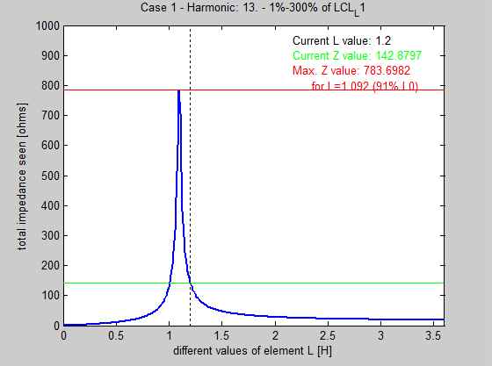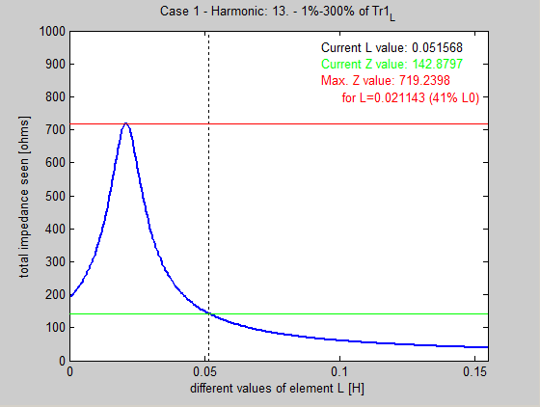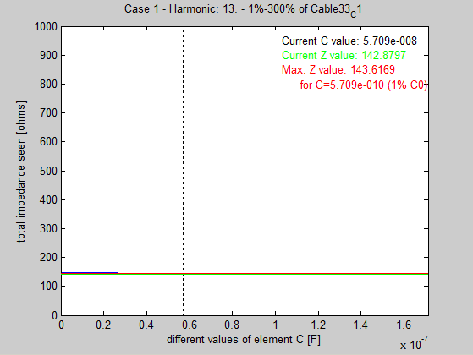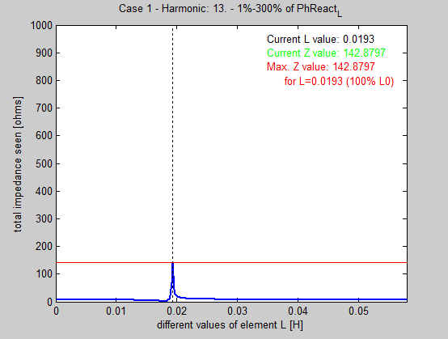

From these graphs you can see what would be change of total impedance seen from middle LCL point if we change the value of element from 1% to 300% (dashed line is original value of L or C). As you see, last graph shows that the current value of phase reactor is at peaking impedance for considered range. Even though the value of impedance is relatively low comparing to first two elements whom influence seems more significant, the regulation of this element (phase reactor) causes more significant changes in overall frequency sweep for whole grid. You can see it below (dashed line is original frequency sweep, while blue is after change of value of one particular element – phase reactor:

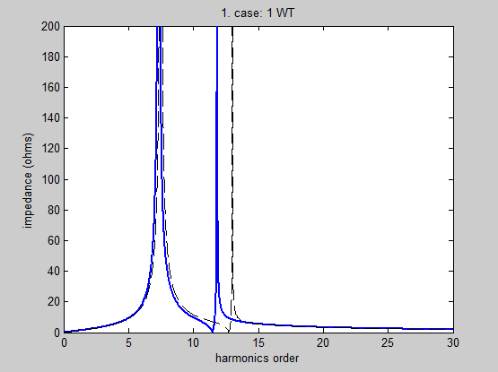

Moreover, similar plot we obtain for closest capacitor of phase reactor (tuned C filter – first capacitor from the grid side):

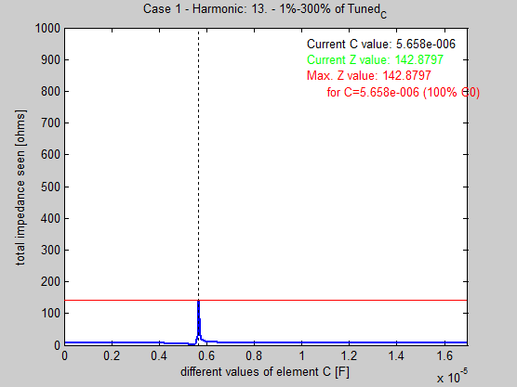

These two elements are in parallel and change of value of one of them leads to significant change of frequency sweep (significant comparing to other elements influence).

Thus, I would conclude that probably resonance between this two elements is the source of resonance for this grid. Very close to peaking impedance value is also Transformer no. 3 which is next to phase reactor and tuned capacitor, so transformer 3 probably is also strongly involved in this resonance.

As a “confirmation”, in DigSilent this harmonic disappears if you exclude phase reactor, tuned capacitor and transformer from the grid.

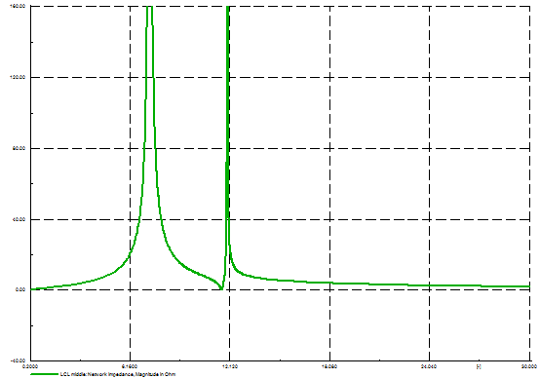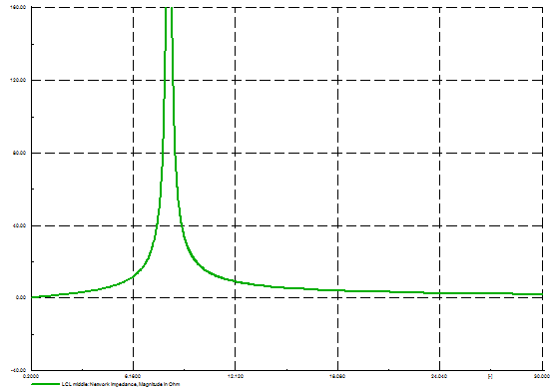

Secondly, if you want to get rid of other harmonic order that you can see in original frequency sweep graph (order 7.5) (basically switch it to another value), two elements are identified, also directly in parallel to each other: first inductance of LCL filter and LCL capacitance:

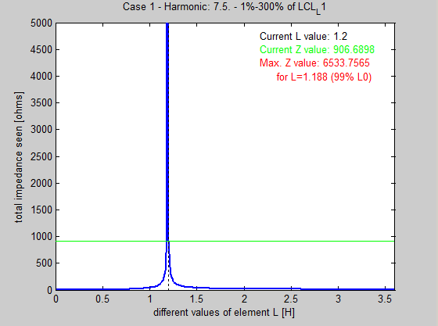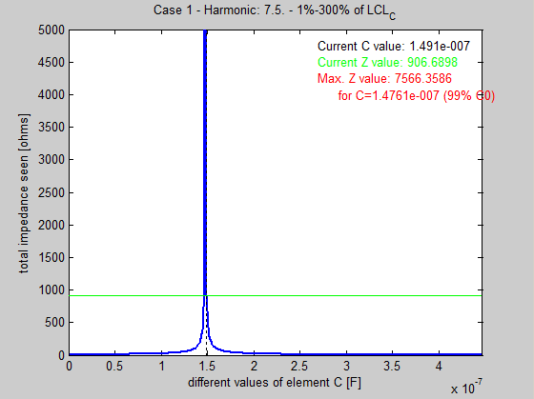

Similarly, modulation of these two values leads to much more significant changes in 7.5th harmonic for the grid (still seen from the same point) than modulation of other elements.

Analysis on the basis of these graphs gives some clues of elements involved in emission of each harmonics however I am not sure about that since each change of parameter leads to complete change of others plots, values etc., therefore seems not very reliable. What do you think?

(Zip pack of scripts and other essential files included if you want to check: *Aalto_cases* script gives frequency sweep, and *Aalto_elements_analysis_case1* script gives graphs for modulated (1%-300% every 1%) LC elements. Reference values of elements could be changes at the beginning of those files, also harmonic value *h* to be changed for analysis of different harmonic order).

The method that is „recommended” in identification of elements/buses responsible for emission is Harmonic Modal Analysis. It enables to find some participation factors and to carry out a sensitivity analysis to identify the bus which excites the resonance. I still wonder if I should try to make it or skip ☺. If you have some papers describing the method I would have closer look into it. Thanks in advance.

Finally, I also found yesterday another paper where they use the model I am using and some details are clarified. Unfortunately, it will lead to some changes in the values of the model I currently have.

**Regarding modelling of exemplary full WPP** I have combined model of 100 WT similar like in one of the papers, however it is probably different since the description in not very extensive.

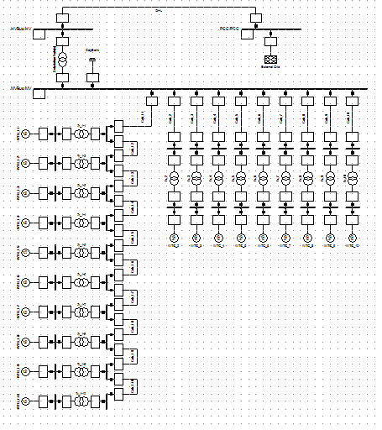

It works, however I have not analysed it very deeply yet.